L U M S D E N S C H O O L
Newsletter Issue 20 – July 8th 2016



Contents
Page 1
- Principal’s Letter

Page 2
- Looking Ahead 2016
- ERO Report
- Additional Students Travelling on Dome Network Buses
- Young Leader Award

Page 3
- Welcome to School
- VIP of the Week
- 50¢ Book Sale – Start of Next Term!
- Rugby International
- Soccer Results

Page 4
- Congratulations
- Rugby Results
- Entertainment Books Available Now
- Teddy Bear’s Picnic
- Volunteers Needed
- One for the Girls

Page 5
- Southfuels – Fuel for Schools

Attached:
- ERO Report

NEWSLETTERS

Please

- Look for it on a Friday afternoon

- Take note of anything needing attention

- Return slips as soon as possible

Dear School Friends and Families

It must’ve been a fun term, if that’s what makes time fly!
Next term is even shorter (9 weeks) so there’ll be never a
dull moment as we pack it with some pretty full-on learning experiences which culminate in Polyfest (Week 6) and the “Magic School Bus” School Production (September 22). The Olympic Games always provide a fantastic context for learning, and as part of this, each class will be having a focus on learning about a different country.

Meanwhile, this term has finished with a flourish. At our special leadership assembly on Wednesday, Westpac Business Development Manager Murray Heath presented Cade McLachlan with this year’s Sir Peter Blake Young Leader Award. There are only 300 of these awarded across New Zealand, and Cade’s quiet helpfulness, initiative, reliability and excellent attitude towards all school activities have made him a very worthy recipient. Congratulations, Cade.

It was a shame that Todd Barclay’s plane was held up in
Christchurch today so that he was unable to attend our Duffy
Assembly as planned. However we will reschedule his visit for
next term some time. Meanwhile the children still have their books to bring home and enjoy during the holidays. We appreciate the time-consuming work Miss Bray does to prepare the books for these Duffy Books occasions, collating the class boxes based on the choices that children have made.

Speaking of Support staff work, we took the opportunity to
acknowledge their excellent inputs into the school with a
special morning tea on Monday. Thank you Sharon, Lyn, Jackie, Sue, Sam and Jennifer for the dedication, expertise and high standards which you all bring to your work.

On Thursday, myself and the teachers spent some quality time looking at the Education Council’s Practising Teacher Criteria, which are what all teachers need to meet for Teacher Registration issuing and renewal. It’s always useful to revisit these and come up with what these do or should look like in our work, and to reflect on them in terms of continuous improvement. We also reviewed our report format with a view to informing parents of progress against National Standards without the use of ‘below’, ‘at’ ‘above’ boxes’, as we’re conscious that students seeing themselves as ‘below’ risks breaking confidence and positive learning disposition.

As most of you will know, today is the last day for NSC principal Trevor McKinlay. I have greatly appreciated his collegiality and support, and wish him all the best for his retirement following a long and illustrious career.

Looking forward to launching our new ‘Active Supervision’
staff duty programme at the start of next term. More about
that in our next newsletter. A huge thanks to Sonya Hoffman
for her sewing effort this week putting pockets inside our new staff high-viz vests. The children will find out what goes inside them next term ☺.

Hope the holidays go well at your place, and that we don’t need raincoats over winter woollies to pay for this great winter we’ve been having! Ka kite ano,

Andrew Watson
Principal

Thur




Reminder: text follow lumsdenschool to 8987 so that you will receive immediate text notification of alerts and reminders via our twitter account (e.g. snow days, cancellations).




Looking Ahead 2016
Monday | Tuesday | Wednesday | Thursday | Friday | Saturday | Sunday
25 Start of Term 3 | 26 | 27 | 28 | 29 | 30 | 31
1 Aug | 2 | 3 | 4 Speeches – Senior Classes | 5 Variety Dash here 10.50 – 12.30 | 6 | 7
8 | 9 BOT Meeting | 10 | 11 | 12 | 13 | 14
15 | 16 | 17 Northern Speeches, Mossburn | 18 | 19 | 20 | 21
22 | 23 | 24 | 25 | 26 | 27 | 28
29 Polyfest one day this week, at Invercargill | 30 | 31 | 1 Sept | 2 | 3 | 4
5 | 6 St John in Schools | 7 | 8 | 9 | 10 | 11
12 | 13 BOT Meeting | 14 | 15 | 16 | 17 | 18
19 School Photos | 20 | 21 | 22 Production | 23 End of Term 3 | 24 | 25

Education Review Office (ERO) Report
This is attached for your interest. It has a very positive ‘flavour’ and it is great to have such positive affirmation about what we’re doing from an external point of view.

Additional Students Travelling on Dome Network Buses
From time to time parents may wish for additional students to accompany their children home on a school bus. There may also be times when a parent wants a student to travel on a different bus to their normal one for a special event such as sports practice.

The Dome Network is happy to support this practice but it must take place in a safe and organised manner. If you want additional students to come home with your children the onus is on you to make contact with the bus driver to ensure that there is sufficient space on the bus. If the driver is satisfied that they will not have an over-loading problem they will agree to transporting the additional passengers. At this time the parent making the request is required to supply the names of the additional passengers to the bus driver, and contact their school to let them know.

Please be advised that additional passengers on bus services are required to meet the high expectations of good behaviour. Any students found to misbehaving or otherwise inconveniencing existing students will be prevented from travelling again in the future.

Young Leader Award
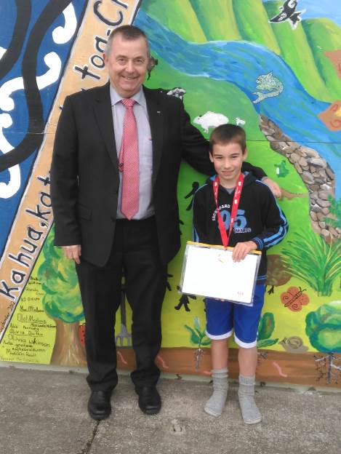

Congratulations to Cade McLachlan, our Sir Peter Blake
Young Leader Award recipient, pictured here with Murray
Heath from Westpac who came to present Cade with his
Medal and Award pack.

Welcome to School

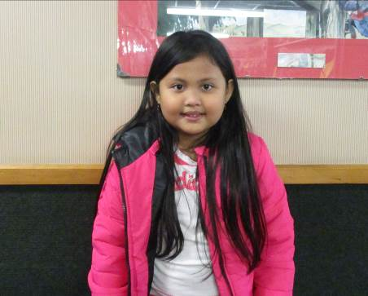
Today we are pleased to welcome Abbie Mendoza to Room 5. We hope you enjoy your time at Lumsden School.

VIP of the Week
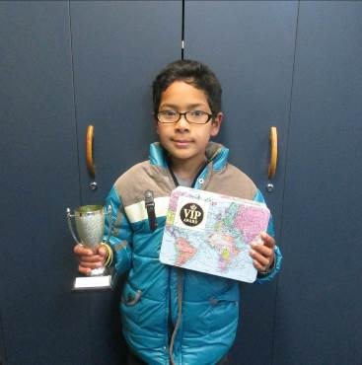

Congratulations to Aayush Dhakal, last week’s VIP recipient, for great manners and thoughtfulness.

50¢ Book Sale – Start of Next Term!
The Non-fiction section of the library has recently been “weeded”, and we would like the opportunity for families to have any they wish (50¢ a book). Stand by for more information at the start of next term.

Rugby International
A huge thanks to Tua Tuapati, professional rugby player, for his time with each class on Monday teaching them some basic skills. We have enjoyed having Kitione (Tua’s son) with us over the past month, while Tua has taken an off-season break from his professional club in Marseilles (France).
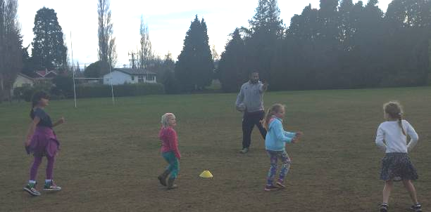
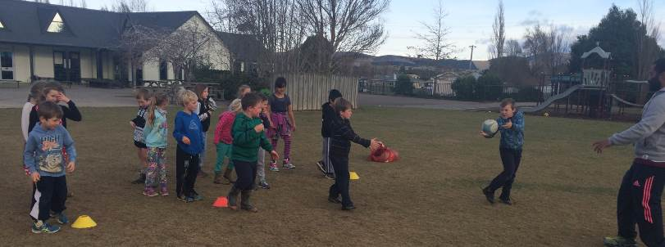

Soccer Results
9th Grade
Winton Lumsden 2
Old Boys Falcons 4
Player of the Day: Andrew Graham

12th Grade
Winton Lumsden 1
Old Boys Glory 4
Player of the Day: George Naylor

Congratulations to Fynn Mitchell, who has made it into the Northern
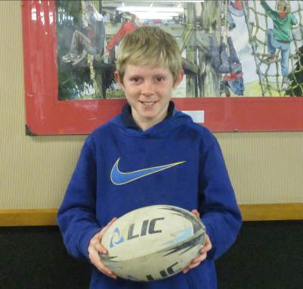
Under 38kg rugby team. His first game is this coming Sunday.
Well done, Fynn!

Rugby Results
Won by Default.

Rippa Rugby: George Munro was Player of the Day

Entertainment Books Available Now
2016/2017 books are now available at the school office or online. Books cost $60 each and the school receives $12/book profit.

Room 1 Teddy Bear’s Picnic



Room 1 children enjoying lots of yummy treats during their Teddy Bear’s Picnic this morning as they wished Lara, Amelia and Laurie (pictured right) all the best for their move through to Room 4 next term.

Volunteers Needed
Proofreaders are required for the new local phone directory. This will involve 1½ - 2 hours one evening during the school holidays. A percentage of the proceeds will go towards the Lumsden Community Pool. If you are able to help please phone Cheryl Clearwater 248 7110 or 027 615 5903.



